Baltimore students start the day with mindful exercises
Mindfulness in school
February 19th, 2019
By Ivanhoe Newswire

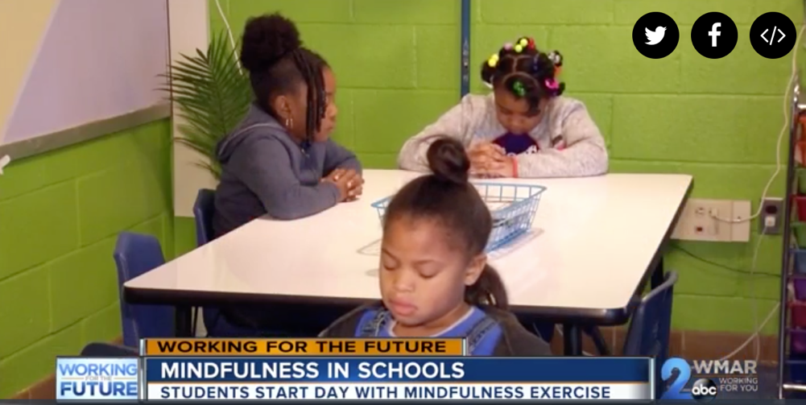
BALTIMORE, Md. — Mindfulness training was once synonymous with yoga studios. These days, even major corporations offer the training to employees.
Mindfulness practices involve focusing on the present and on breathing. Now researchers at Johns Hopkins University are studying effects of this training on students in urban elementary schools.
Before students at this Baltimore city public school start reading and writing, they begin the day with time to reflect. Students lead a daily two-minute mindfulness exercise. Like many other districts in urban areas, kids here face challenges outside these school walls.
“A lot of these students are coming into school in a state of fight or flight,” detailed Tamar Mendelson, PhD, of Johns Hopkins University.
Mendelson analyzed mindfulness instruction in Baltimore city public schools. Elementary students were trained on breathing techniques and yoga poses for 45 minutes, four times a week for 12 weeks. Before and after participating in the program, students were surveyed about how they reacted to stress and about their mood and emotions.
“Their scores on the survey showed they were better able to respond to stress with less emotional arousal,” Mendelson told Ivanhoe.
The surveys suggested that the kids had less rumination, and fewer intrusive thoughts.
At Liberty Elementary School, there’s a mindful moments room. A certified instructor leads students through exercises, if they seem stressed in the classroom.
“Usually when I close my eyes, I feel like I’m in a different universe,” said fifth grader Marlon Holloway.
“I feel like I’m calm, relaxed and I can get the day on without getting into any trouble,” detailed fourth grader Jalen Brown.
Emily Federowicz, mindfulness instructor at Holistic Life Foundation, said, “Hopefully learning these mindfulness skills will stick with them for the rest of their lives.”
The non-profit Holistic Life Foundation provides the mindfulness instruction at Liberty Elementary School and more than a dozen other Baltimore area schools.
Produced by Child Trends News Service in partnership with Ivanhoe Broadcast News and funded by a grant from the National Science Foundation.

