Dole And ShopRite Bring “Learning Garden” To Liberty Elementary School

August 3rd, 2018

By Alisa Hyman

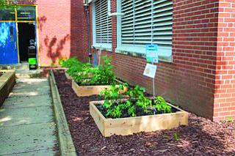

The students and faculty of Liberty Elementary School were involved in a very special event on Thursday, June 7, 2018. Jacob Klein of Klein’s ShopRite of Maryland joined Dole Packaged Foods to mark the donation of a Captain Planet Foundation Learning Garden to their school.
The students had an opportunity to sample vegetables from a garden they planted several months earlier and cared for themselves. Using special planter boxes the students built with the help of Turner Construction Company, they planted seeds and took turns watering the plants and pulling weeds. The students worked with art teacher and garden project coordinator, Marnee Keith, to design the garden and determine where the vegetables should go.
To celebrate their hard work over many months, the ceremony honored the students and faculty at Liberty Elementary School for their hard work, and rewarded their efforts with fresh salad made with vegetables from their garden at the school.
The Project Learning Garden Program is designed to provide context for students to learn outside the classroom in enriching, hands-on ways. Students learned about what happens to seeds planted in the classroom during science lessons and outside in their very own garden. One of the most important lessons that students learned as a result of the partnership with Dole and ShopRite is the value of eating healthy food and balanced nutrition.
Projects like these extend far beyond the classroom. Students take the information home that they learned in school from their garden project to their parents and try to encourage them to eat more fruits and vegetables.
“The younger students just know that their groceries come from the store,” said Liberty principal Joseph Manko, “but to actually see those items grow
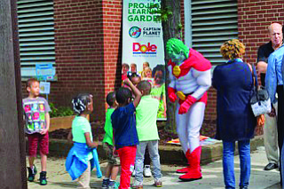
before their eyes and to be able to harvest them and use them in an edible salad— something that’s healthy and tasty, instills in the importance of nature and ecology, and how we can use what they’re growing to nourish their bodies.”
Perhaps the best part of the event, were the smiles on the student’s faces as they excitedly talked about their role in planting the vegetables they were eating. They were eager to talk about how they put seeds in the dirt and took time watering their gardens until they saw the green spouts growing. The excitement in the students was palpable as they all talked about how delicious their salads were. One little girl wondered aloud, “I wonder if my mommy could make this at home?” It looks like this project is having exactly its intended response.
It didn’t hurt that Captain Planet was on hand to flex his muscles and show his support for the garden project representing the Captain Planet Foundation, a partner in this garden initiative.
The Captain Planet Foundation is a grant-making foundation that has funded thousands of hands-on environmental awareness projects for schools and non-profits that serve students in all 50 states and 32 countries around the world.
The students continue to maintain their garden. They have a watering schedule in place and are all eager to do their jobs to ensure that their garden continues to grow delicious fruits and vegetables for the community to enjoy.
Perhaps gardens like the Captain Planet Learning Garden at Liberty will inspire more community gardens that can grow food and foster unity in Baltimore’s neighborhoods and communities.

