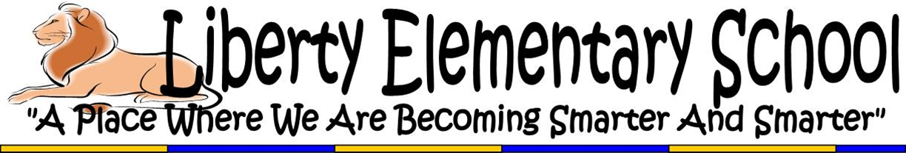
Question And Answer- Updated March 28th

Listed below are a series of anticipated questions and their answers currently. This is a very fluidly moving situation and things are subject to change. These are our best answers at this point.

What is the timeframe of the school closure?
The period of school closure will continue through Friday, April 24th. As of this point, schools throughout the state are scheduled to re-open on Monday, April 27th. This date is subject to change as the situation develops.

Who needs to report on what days?
- As of this point, staff should plan to return on Monday, April 27th.
- Principals are expected to work from home throughout the closure period and will return to school on Monday, April 27th. Principals are encouraged to not go to the building except for special circumstances. If you need to get into the building, let Mr. Manko know and we can schedule a time to open up the building for you.
- It is unclear what the work expectations are for custodians during the closure period. At this point, the entire school has been disinfected and cleaned. We will report on their hours of work as more information becomes available.

How will instruction be delivered during the closure?
- The district has created grade level packets that will be available for parents to pick up at one of the eighteen food distribution sites throughout the city. The three closest food sites to Liberty are Arlington Elementary, Gwynns Falls Elementary, and Pimlico Elementary/Middle School.
- We will be uploading the district packets each week to the grade level websites so that there is grade level work available for each student. At this point, teachers are not expected to make their own grade level packets, however if you have additional resources you want uploaded to the website, please pass this information along and we can post those materials.
- Grade level teams should use the elements of the action plan that was created on Friday, March 13th to determine the strategy for instructional delivery during the extended closure period. We should work on providing as many online resources to students as possible and use creative strategies to deliver instruction.

What is the status of timelines for observations, SLOs, ANET, MISA, MCAP, and grades?
This has not been made completely clear by the district or the state and is still a negotiation between City Schools and the bargaining units. It is hard to speculate at this point, but we suspect there will be major flexibility on all these measures, including state testing for the 2019-2020 school year.

What are staff expectations during the closure?
- We are asking staff to check their City Schools email at least once a day as that will be the main form of communication between the District and Mr. Manko/Ms. Krauss regarding updated information.
- Participate in the weekly staff meeting Zoom call, each Monday at 9:30 am.
- Make an honest attempt at phone contact with each student/family in your classroom at least once a week.
  - Respond to questions posted by students using online platforms
  - Create online lessons and blended learning opportunities for students. There are several great examples of this from your colleagues including You Tube channels, posting in Google Classroom, postings on Class Dojo, old fashioned pen pal letters, phone conferencing and face timing with kids, etc.
  - Respond to parent/family emails
- Work to prepare instructional materials that could aid you in the 2020-2021school year.

How will we communicate to kids and families during the closure?
We have a home learning page through the www.LibertyLearns.com website. The page links off of the main homepage and has home learning resources for all students. The page is broken down per grade level and will include links to online portals (Zearn, Monkey Math, Google Classroom, Common Lit, Epic, Xtra Math, Prodigy, etc.) as well as printable resources. This portal provides access to video resources through You Tube, Zoom, recording of daily instruction, etc.

How will kids be fed during the closure?
The district has set up eighteen food distribution sites throughout the city. The three closest food sites to Liberty are Arlington Elementary, Gwynns Falls Elementary, and Pimlico Elementary/Middle School. The food sites will also be the locations for home learning packet distribution.

Will we need to make up the days from the closure?
This has not been made completely clear by the district. It is hard to speculate, but due to the severity of the situation I would assume some days may be required to be made up, but clearly not all of the days.

